**Fluid Stratification: Taylor Columns**

**The Wavetable Project**

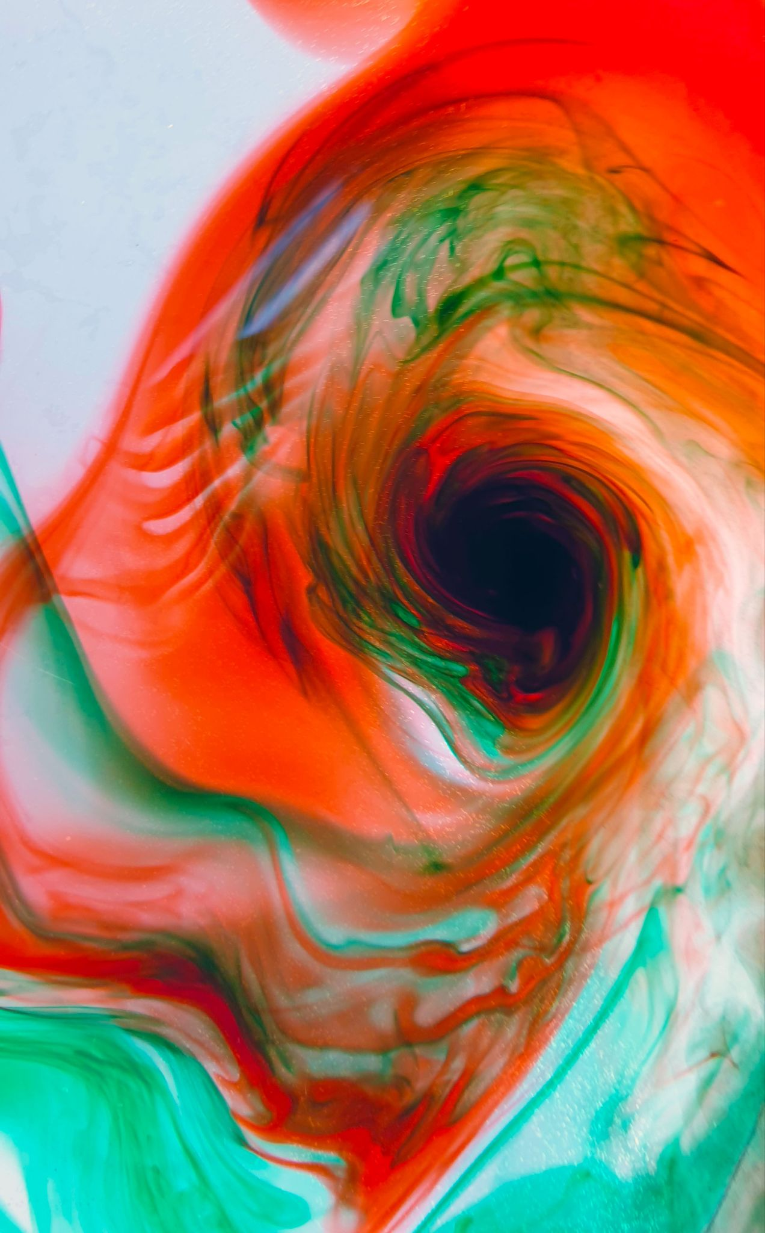

**Figure 1.** A Taylor column in a fluid. [6]

**Before you begin, you will need:**

1. Wavetable
   1. With a CIRCULAR tank
2. Hockey puck
3. Food grade dye OR hole punched holes
4. Camera or iPhone
5. A computer that can connect to the camera. (Secondary Screen)

**Safety:**

1. Keep all exposed wires away from the water tank
2. Keep all long hair tied back and away from any spinning parts of the setup
3. **To demonstrate the Taylor Proudman Theorem, and Taylor columns, begin by placing your hockey puck (or other heavy circular objects) in the bottom of the tank, away from the center of rotation. Proceed to fill the tank to the desired level and begin to spin the tank up to set 0.2.**

*Please read:*

The Taylor-Proudman theorem in fluid dynamics states that when a solid object is moved slowly with a steady angular velocity in an inviscid homogeneous liquid, the fluid’s velocity will be equal along any line parallel to the axis of rotation. [1] These lines are called fluid columns. In other words, a solid object can disrupt the flow in a column above it under certain conditions.

The effect can be demonstrated by placing a solid object, such as a hockey puck, inside a filled tank on a rotating turntable, and observing the flow around the puck. While observing the fluid pass around the puck, you will notice that even though the puck is only so tall, the water flows as if the puck’s height is that of the depth of the water in the tank. The mathematical derivation (not required) is given in Appendix A.

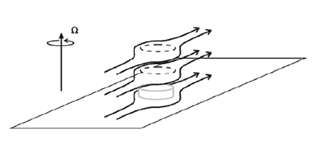

**Figure 2.** The theoretical flow of the fluid around the puck as demanded by the Taylor-Proudman theorem. While the puck is not as tall as the depth, the water flows as if it is. [2]

This phenomenon is apparent because the Taylor-Proudman theorem gives us the statement that “fluid columns cannot be stretched in the direction of the rotation vector Ω” [2] and so the fluid moves along constant depth contours; and as mentioned earlier, the velocity has to be the same on each of them. So if the velocity and depth must be the same for each fluid column, then the horizontal flow must be the same on **every single** level. Because the flow must be equal in all depths, the fluid will flow around the puck as if the puck’s height were the same as the depth of the fluid in the tank. This phenomenon can also be seen as an instance of the Coriolis effect.

1. **Once the tank has been spinning at set 0.2 for 10+ minutes, drop either your hole punched holes, or your food dye into the tank, a few inches in front and behind the hockey puck. If you are using food dye, make sure to drop a few drops in sequence, in the same location. After a few seconds, and once the dye has settled, slow the rotation of the tank to set 0.15 so that the water will move into and around the hockey puck (or similar object).** *BEWARE: this is a hard lab to execute, and it may take a few attempts.*

Watching the feed from the overhead camera, did Taylor columns form? If not, what seemed to happen instead? Did the water rush past too quickly? Not quickly enough? Write down what happened and how you are going to improve the result.

|  |
| --- |

1. **Now let’s put your theories to the test. Reset the apparatus and take notes on what variables you will be changing in this trial.** *Note: If you choose to change the rotation rate, do not have too large a difference, or else the delicate pressure balance will be washed away.*

| **Changing variable** | **Observations on how it changed the system** |
| --- | --- |
| Write your own: _______________ |  |
| Write your own: _______________ |  |
| *General notes:* |  |

*Please read:*

The main force behind the Taylor Proudman effect is the Coriolis force. As discussed in the Lab #2, the Coriolis effect or force is an inertial and technically fictitious force that “acts on objects that are in motion within a frame of reference that rotates with respect to an inertial frame.” [3] The result of this effect is that when you trace the path of an object in motion with relation to the rotating frame, it is moving in a straight line; but when you observe the motion of the same object from a standstill (not in the rotating/inertial frame) it moves in a curve shape. This is illustrated in the diagram below.



**Figure 3.** The upper image shows the path of an object in the inertial/rotation frame of reference, and the lower image shows the same object’s motion but from a standstill, noninertial frame. [5]

The tendency for objects (and fluids) to circulate with respect to the non-inertial frame causes Taylor columns. They are columns of (seemingly) circulating water, caused by the presence of the (in this case) puck in the tank because it creates a low-pressure zone on top of the puck into which the water flows.

1. **Repeat the experiment if necessary, and after recording your observations, slowly reduce the speed of the turntable and dismantle the setup.**

**Appendix**

**A**

(**Ω**•∇) **u** = 0 -------------------------------------------- 1

Where Ω is the rotation vector, **u** is the fluid velocity (this can be derived from the Navier-Stokes equations). This equation says that the vector field **u** has no variation in the direction of Ω. Assuming that Ω is about the z-axis, the inner product of ∇ and Ω will be $Ω\hat{ z}\frac{d}{dz}$ as the value of Ω is 0 in the x and y; or put into words, the result of the inner product of ∇ and Ω is the product of the derivative in the z-direction and gradient of Ω in the z-direction. If the gradient in the z-direction, of u, is equal to 0, it means that the z-direction of the fluid velocity does not change!

$Ω • ∇=(Ω \hat{x} )(\frac{d}{dx})+(Ω \hat{y} )(\frac{d}{dy}) + (Ω \hat{z} )(\frac{d}{dz})$------------------------------- 2

Because Ω is a rotation vector about the z-axis, it does not have any movement in the x or y planes, so $Ω \hat{x}$ and $Ω \hat{y}$ both equal 0.

$Ω • ∇=(Ω \hat{z} )(\frac{d}{dz})$------------------------------------------- 3

$(Ω • ∇)u=(Ω \hat{z} )(\frac{d}{dz})u$----------------------------------------- 4

$(Ω • ∇)u=(Ω \hat{z} )(\frac{d}{dz})u = 0$------------------------------------ 5

And if the derivative or rate of change in the z-direction along Ω is equal to zero, then the vector field **u** must not have any movement in the z-direction as well. Meaning that the fluid columns always flow along a constant depth contour.

**Glossary**

* Inviscid
  + A liquid or substance where the viscosity is negligible
* Homogenous
  + A homogenous solution has the same properties at every single point
* Angular velocity
  + How fast an object revolves around a given axis of rotation
* Fluid velocity
  + The velocity of a given fluid
* Fluid column
  + The individual lines, representing the flow of the fluid
* Contours
  + Individual lines represent a constant depth/height of something along the line
* ∇
  + The gradient operator. The sum of the derivatives in the x, y, and z directions.
* Dot product/inner product
  + The mathematical operation of mapping of one vector onto another
* Derivative/ $\frac{d}{dx}$
  + The instantaneous rate of change of a function in a given direction
* Inertia
  + Is the tendency of an object to continue in its existing state of motion or lack thereof

**References**

1. Wikipedia. “Taylor–Proudman Theorem.” *Wikipedia*, Wikimedia Foundation, 31 Aug. 2020, en.wikipedia.org/wiki/Taylor%E2%80%93Proudman_theorem.
2. MIT. “Taylor Columns: Introduction.” *Weather in a Tank*, weathertank.mit.edu/links/projects/taylor-columns-introduction.
3. “Coriolis Force.” *Wikipedia*, Wikimedia Foundation, 4 Nov. 2020, en.wikipedia.org/wiki/Coriolis_force.
4. National Geographic Society. “Coriolis Effect.” *National Geographic Society*, 9 Oct. 2012, [www.nationalgeographic.org/encyclopedia/coriolis-effect/](http://www.nationalgeographic.org/encyclopedia/coriolis-effect/).
5. By Hubi - German Wikipedia, CC BY-SA 3.0, <https://commons.wikimedia.org/w/index.php?curid=1008114>
6. https://en.wikipedia.org/wiki/Taylor_column?scrlybrkr=9fb12b41